SVCR GOVERNMENT DEGREE COLLEGE, PALAMANER
IQAC – ALUMNI FEEDBACK ON CURRICULUM 2025-26
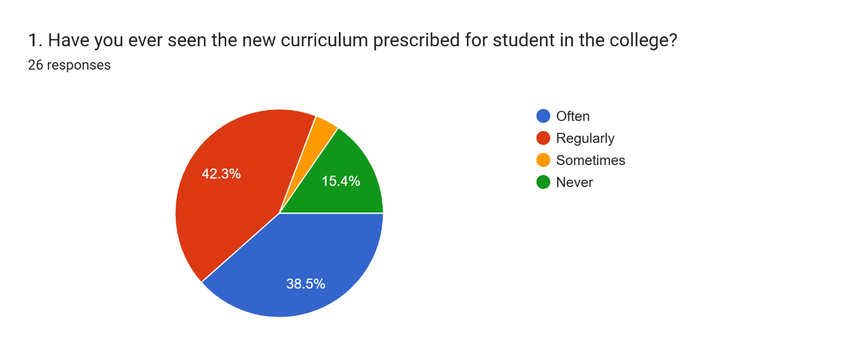
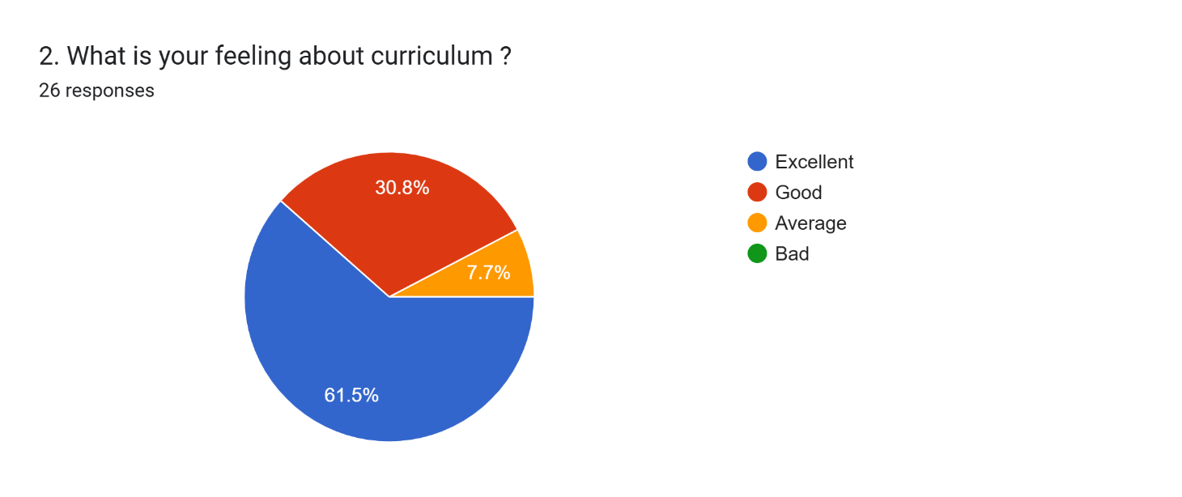
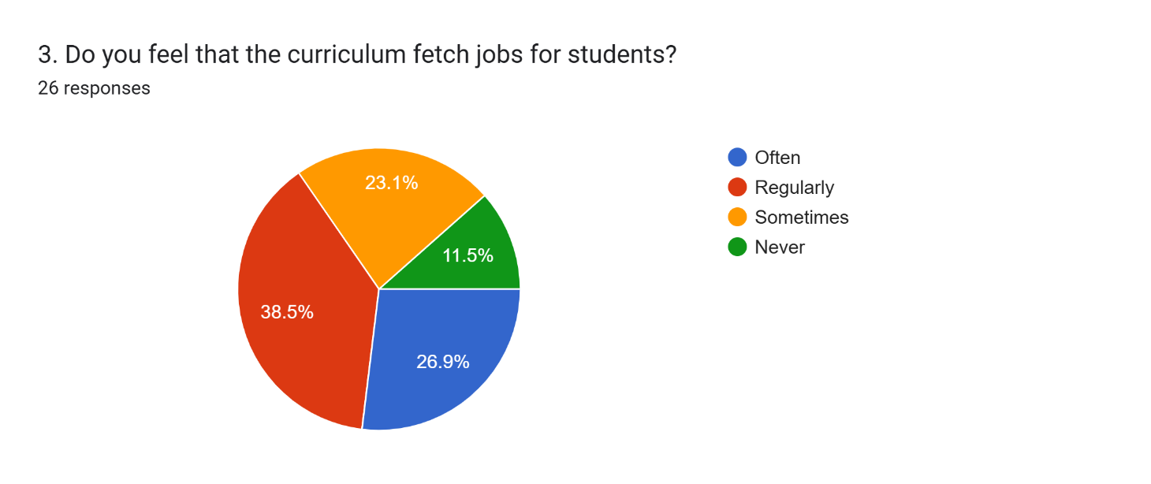
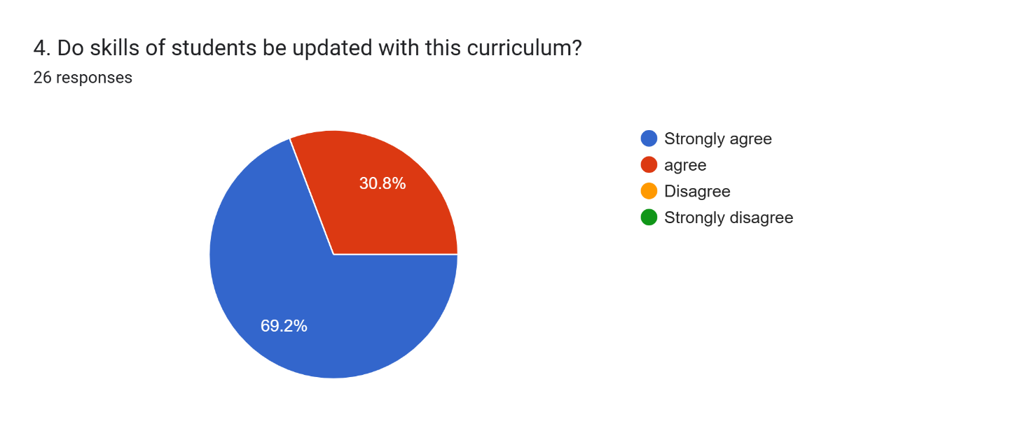
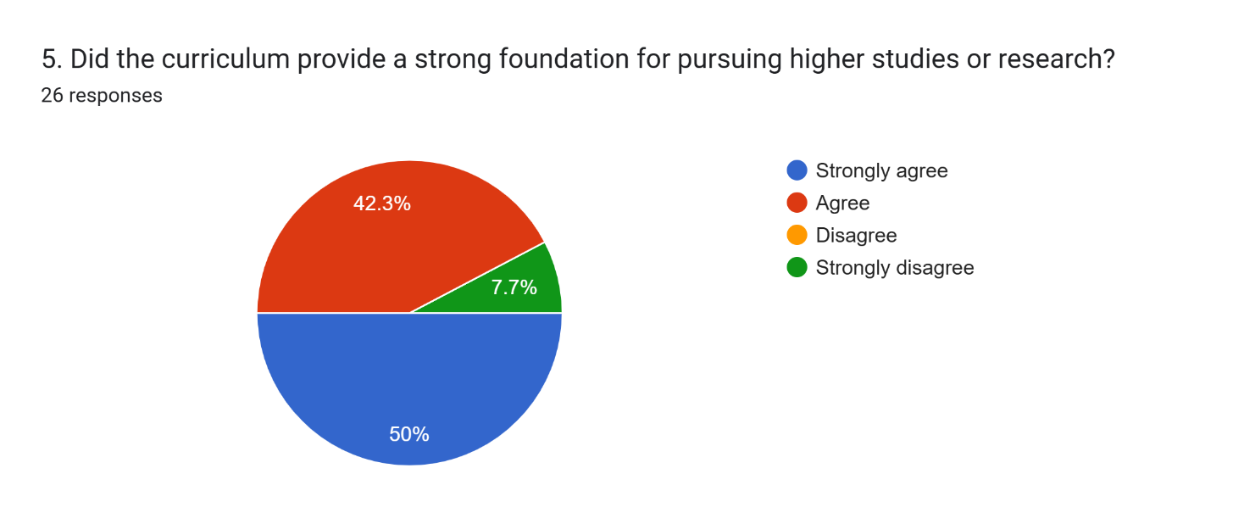
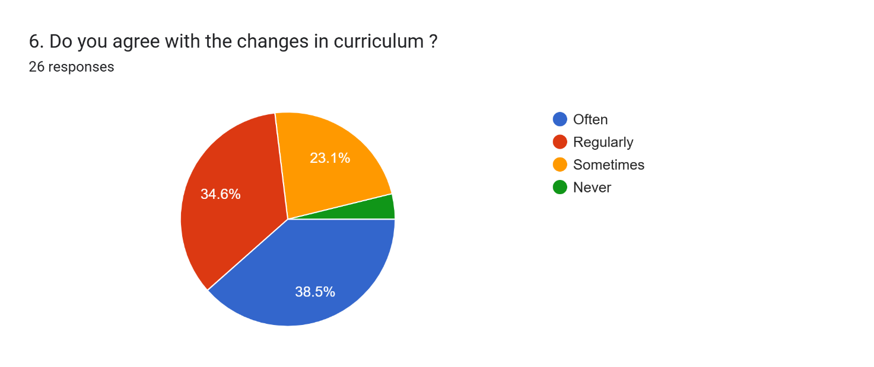
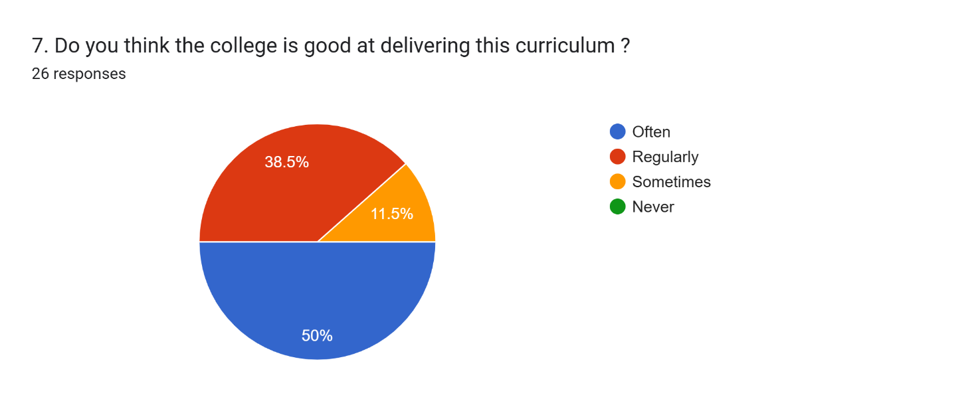
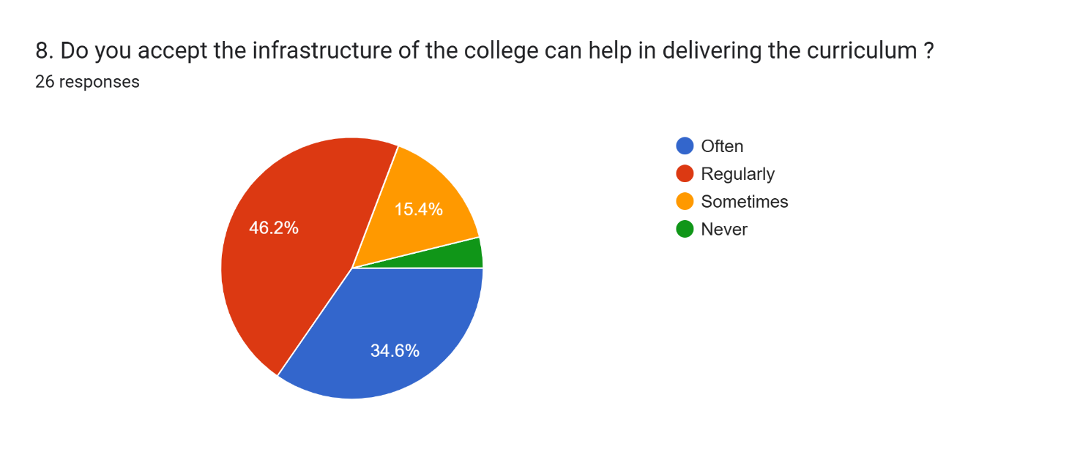
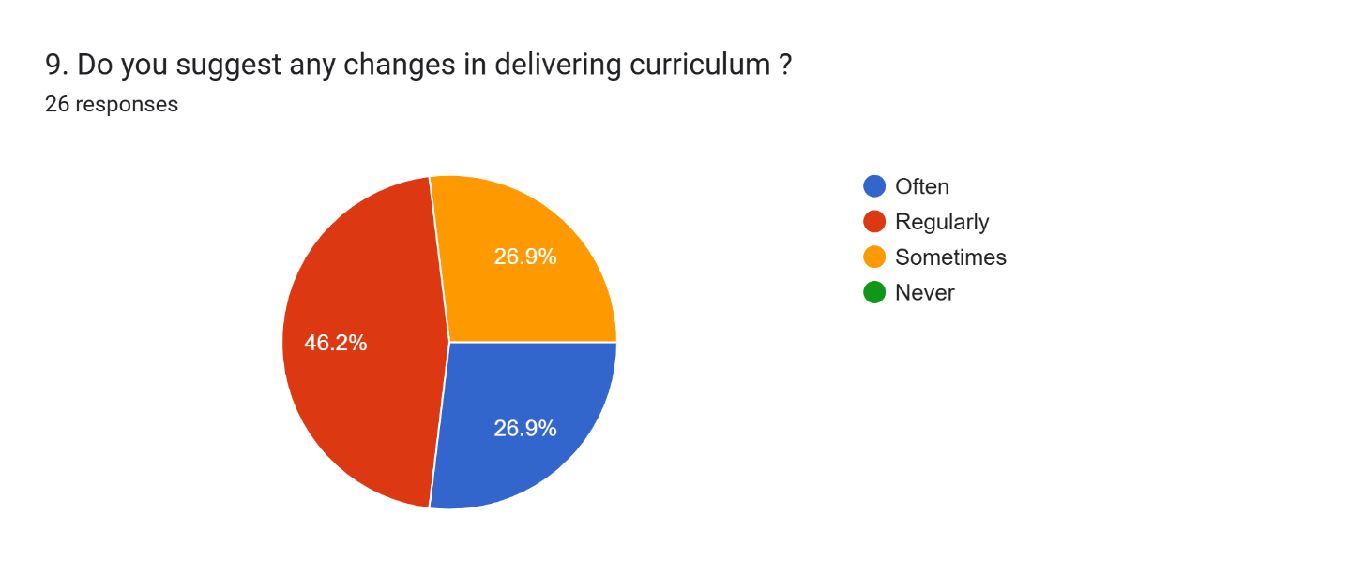
10. If so mention any one of the changes you expect ?
Jobs
Library needs improvement
Campus Cleaning near main gate BA Block and near stage
No changes
Professional courses
More practical exposure
Nothing
No changes
No changes
I feel Job is important in farther future
Pakka building
No
No
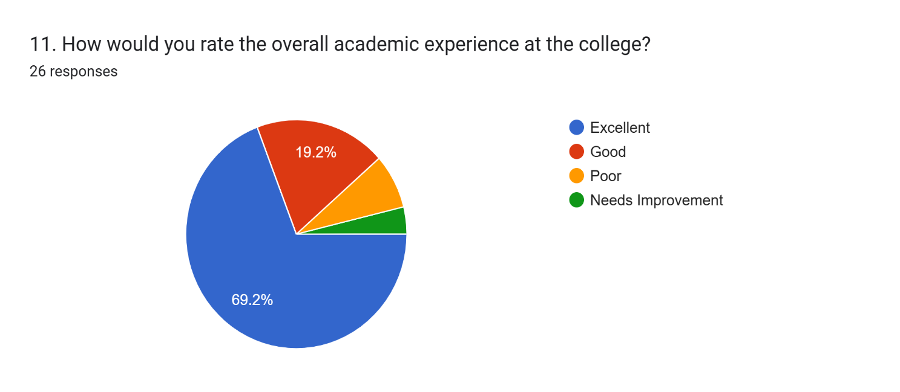

Consolidated Alumni Feedback on Curriculum (2025–26)
The overall feedback from alumni indicates a generally satisfactory perception of the curriculum. Most respondents expressed no major need for changes, showing that the existing curriculum meets basic expectations.
However, a few important suggestions were highlighted:
- Employment Focus: Several alumni emphasized the need for job-oriented courses and better career opportunities in the future.
- Practical Exposure: There is a suggestion to include more practical learning and skill-based training.
- Infrastructure Improvements: Some respondents mentioned the need for:
  - Better library facilities
  - Improved campus cleanliness
  - Development of proper buildings and infrastructure
- Professional Courses: A few alumni recommended introducing more professional and career-oriented programs.
Conclusion
While the majority of alumni are satisfied with the current curriculum, there is a clear expectation for enhanced employability, practical exposure, and infrastructure improvements to better support student development.

